PRODUCT MANAGER · CASE STUDY
Speed-to-Lead: Solving Lead Response Failure in Real Estate
AI Voice Agent for Brokerages
A zero-budget validation sprint — from problem discovery to product architecture in six weeks
Role: Founder & PM | Timeline: Jan – Mar 2026 | Market: Florida real estate brokerages (US)

Impact Snapshot
67%  No-response rate  30 Zillow inquiries sent | 0%  Weekend response rate  7 of 7 brokerages silent | 4.6×  Higher signal from brokers  vs solo realtors | 2  Warm leads generated  from 173 cold emails

CORE INSIGHT
67% of brokerages did not respond at all.
This revealed that the problem isn't slow agents — it's the complete absence of a lead response system. Brokerages are paying for leads and have no infrastructure to receive them.

THE FINANCIAL STAKES  Typical commission per transaction  ~$10,000  If a brokerage misses 5 qualified leads/month:  $50,000/month in lost revenue  Not a productivity issue. A revenue leak — entirely preventable with the right system. | MARKET CONTEXT  - Avg FL brokerage (10–50 agents): $1M–$3M gross commission/year  - Zillow Premier Agent: $300–$1,000/month per agent  - Industry avg callback: 15 hours  - Lead contacted in < 5 min: 100× more likely to qualify (Verse.ai)  - After 60 min: 10× drop in connection probability

Context & Problem Statement
Real estate brokerages in the US spend heavily on paid lead channels — Zillow Premier Agent, Facebook/Instagram ads, Google — yet systematically lose these leads due to slow or absent follow-up. Research shows:
- Responding within 5 minutes makes a lead 100× more likely to qualify (Verse.ai)
- Waiting 60 minutes drops connection probability by 10×
- The US industry average callback time is 15 hours — at which point the lead is effectively dead

Hypothesis
An AI voice agent that calls within 60 seconds of inquiry, qualifies the lead, and schedules a handoff call with a human agent will be a solution that brokerages pay for on retainer.

My Role & Approach
I ran this as a solo founder-PM — no budget, no team, no existing product. Every decision below was made and executed by me.
PM responsibilities  - Problem framing and hypothesis formation  - ICP definition and qualification criteria  - Experiment design: Zillow audit + email outreach  - Data collection, synthesis, and insight extraction  - Framing and messaging iteration  - Solution architecture scoping | Constraints  - Zero budget — all outreach manual  - No product existed — validation before build  - Two cohorts tested in parallel  - All data hand-collected and logged  - 6-week window from hypothesis to architecture

ICP Definition
Before running any experiment, I defined strict qualification criteria to ensure signal quality:
Cohort 1 — Solo Realtors  - Florida market  - 40+ sales in last 12 months  - Avg price $200K–$600K  - Direct owner email available  - Zillow Premier Agent listed | Cohort 2 — Broker Owners (Primary ICP)  - Team size: 10–50 agents  - Florida market  - 40+ sales in last 12 months  - Avg price $200K–$600K  - Direct owner email available  - Zillow Premier Agent listed

Rationale: I wanted to test whether the pain point was felt more acutely at the individual agent level or at the team operator level — since the two segments require different pricing, framing, and product features.

Experiment 1 — Speed-to-Lead Audit (Zillow Mystery Shop)

Goal  Validate that the problem exists at scale — not anecdotally.  Method  Submitted real buyer inquiry forms on Zillow for 30 highly qualified Florida brokerages across 3 time windows. | Buyer Persona Used  - Pre-approved buyer  - $450K–$550K budget  - Relocating from New York  - Ready to move in 60–90 days  Selected to represent a high-intent, high-value buyer that any brokerage would want.

Results
30  Brokerages audited  Orlando · Tampa · Jacksonville · Fort Lauderdale | 67%  No response at all  20 of 30 — complete silence | 0%  Weekend response rate  7 inquiries sent, 0 replies | 3  Replied in < 5 min  10% of 30 brokerages

Response time breakdown
Response window | Brokerages | Count | % of 30
< 5 minutes | Elite Realty, Lokation, McIntosh Group | 3 | 10%
5 – 30 minutes | Majestic Realty | 1 | 3%
30 min – 2 hours | Green Realty, Luxe Properties | 2 | 7%
2 – 24 hours | Team Donovan (15.5h), JPAR (23.5h) | 2 | 7%
> 24 hours | VantaSure (48h), Core Group (3 days) | 2 | 7%
No response | 20 brokerages — including all 5 weekend inquiries | 20 | 67%

Key insights
Weekend = dead zone
7 buyer inquiries sent on Saturday. 0 responses. These are Tier A/A+ teams with active Zillow Premier Agent subscriptions — paying per lead, answering none.

67% silence is a systems problem, not a staffing problem
20 of 30 brokerages sent zero response across any time window. This isn't a speed issue — it's the absence of any intake infrastructure.

Even the 3 fast responders have no after-hours coverage
Lokation, Elite Realty, McIntosh Group all responded in under 2 minutes during business hours. None had any coverage for the off-hours or weekend windows.

Experiment 2 — ICP Pain Validation (Cold Email)

Goal  Determine which cohort feels the pain more acutely and is more likely to act on it.  Method  Sent cold emails to both cohorts referencing the speed-to-lead problem. Measured response rate, signal quality, and buying intent. | Sample sizes  - Cohort 1 (Solo Realtors): 200 emails  - Cohort 2 (Broker Owners): 173 emails

Results comparison
Metric | Cohort 1 — Solo Realtors | Cohort 2 — Broker Owners
Emails sent | 200 | 173
Response rate | 2.5% (5 of 200) | 3.5% (6 of 173)
High-signal responses | 1 of 5 (20%) | 4 of 6 (67%)
Opt-out / hostile | 3 of 5 (60%) | 1 of 6 (17%)
Buying signals (demo interest) | 0 | 2 — unsolicited
High-signal rate vs sent | 0.5% | 2.3% (4.6× higher)

Notable responses from Cohort 2 (Broker Owners)
Res-5  Pain acknowledged | "We try to respond fast but honestly it depends on the agent. Some leads slip through."  Owns the structural problem. Agent dependency = systemic, not personal.

Res-8  Buying signal | "What exactly does your AI agent do with the lead? Does it call immediately?"  Specific product question — already evaluating fit. Warm lead.

Res-10  Strong interest | "We actually struggle with this. Happy to take a look if you want to show what you built."  Unsolicited demo invitation. Highest-value response in the dataset.

Res-9  Addressable objection | "We already have an ISA team handling inbound."  Not a rejection — an opening. ISA teams don't cover nights, weekends, or national holidays. AI fills the gap they can't.

Verdict: Broker Owners are the ICP
Cohort 2 produced 4.6× more high-signal responses per email sent, 2 unsolicited demo requests, and only 1 opt-out vs 3 from Cohort 1. Solo realtors see the problem as personal — and get defensive. Broker owners see it as systemic — and want a fix.

Product Decisions Driven by Research

Signal observed | Product decision | Rationale
0% weekend response rate | AI agent runs 24/7/365 by default | Biggest pain window is off-hours and weekends — always-on is table stakes
Broker cites agent dependency | Report per agent, not just per brokerage | Broker needs visibility into which agents are the bottleneck
ISA team objection (Res-9) | Position as ISA complement, not replacement | Removing ISA is too threatening — filling their gaps is the easier sell
Solo realtors reacted defensively | De-prioritise Cohort 1; focus on broker-owners | Wrong segment for this framing — different product angle needed
3 fast responders still had no off-hours coverage | Lead with after-hours gap in outreach | Even self-perceived responsive teams have the weekend gap

Solution Architecture
Architecture goal
Design a system that guarantees: (1) response within 60 seconds of any inquiry, (2) 24/7/365 coverage — including nights, weekends, and holidays, and (3) automated lead qualification so human agents only act on verified, high-intent leads.

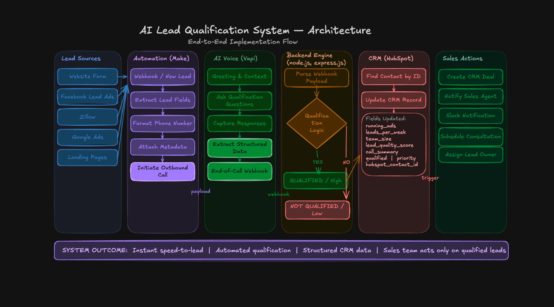
End-to-end implementation flow — Lead Sources → Automation → AI Voice → Backend Qualification → CRM → Sales Actions
Built on existing AI infrastructure — no core technology from scratch. Stack is intentionally flexible to evolve as underlying AI platforms improve:
Lead sources | Zillow, Facebook Ads, Google Ads, website forms, landing pages
Automation layer | Make (formerly Integromat) — webhook trigger, field extraction, phone formatting, metadata attachment, outbound call initiation
AI voice layer | Vapi — greeting, qualification questions, response capture, structured data extraction, end-of-call webhook
Backend | Node.js + Express — qualification logic, CRM update trigger
CRM | HubSpot — contact lookup, record update (lead quality score, call summary, agent assignment, priority flag)
Sales actions | Slack notification to agent, CRM deal creation, consultation scheduling

System outcome
Instant speed-to-lead (< 60 seconds) · Automated qualification · Structured CRM data · Human agents act only on qualified leads

What I Learned as a PM

- Cohort 1 reacted to 'you're losing leads' defensively. The same pain, reframed as 'coverage when you're tied up,' would require an entirely different message architecture — not just copy changes.: Framing matters as much as the solution
- Both experiments were run before a single line of product code was written. The architecture in this doc was informed by real ICP feedback, not assumptions.: Experiment before building
- The ISA team objection wasn't a rejection — it revealed the exact positioning that would make the product non-threatening and immediately adoptable.: Objections are product signals
- The Zillow audit produced timestamped, verifiable data. That's the difference between a claim ('brokerages miss leads') and a proof point ('67% of 30 Tier A brokerages didn't respond at all').: Quantify the problem, don't describe it

Roshan · Founder, Soraaya AI · Case Study — Speed-to-Lead, 2026

